# Sequence Diagrams

**Search Page:**

**Connection Page:**

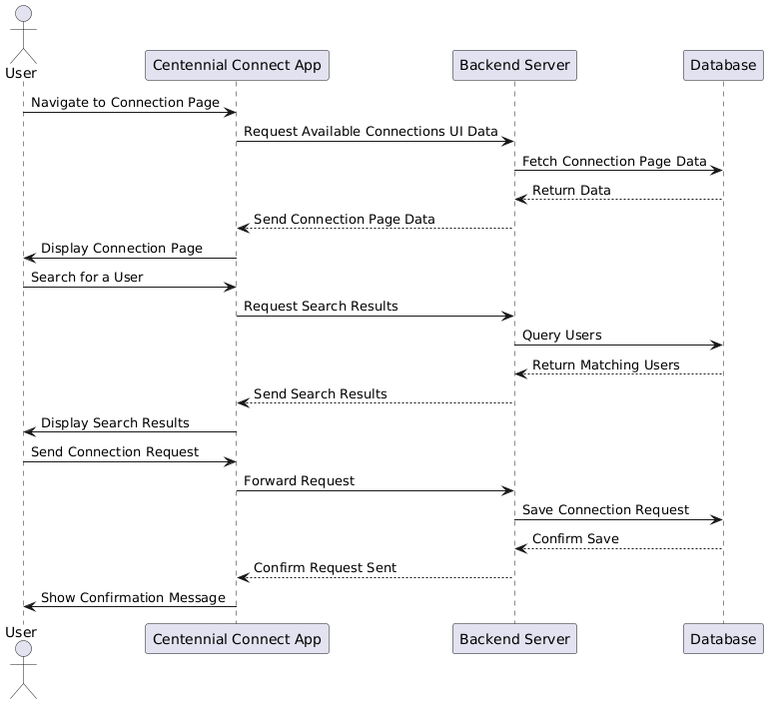

**Connection Database:**

**Event Joining:**

